Hi Team Mores,
It was a cold and blustery morning, the parents were tired but the men were ready to take on Tullamarine in our second away game on the trot.
The men were lucky enough to have no other than The Governor General of Australia Peter Cosgrove's right hand man in Vietnam Stanley Sutherland deliver the pre game message and the men listened with intent. The messages were clear, footy and war had great parallels, you play for your mates and play with integrity, a lot for the little men to take in but a great message that they can remember throughout life.
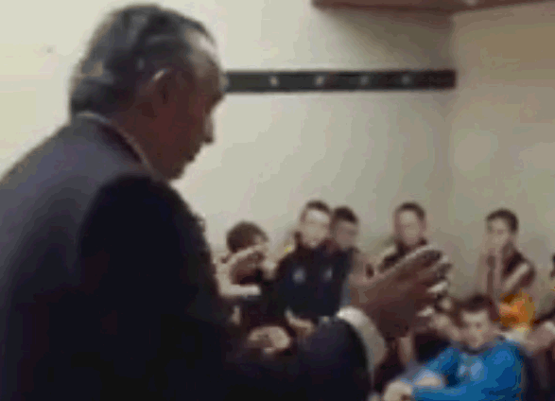
Following a lovely minutes silence for those fallen to make Australia what it is today, a "Good Luck Mate" to their team mates, the first quarter was underway! Needless to say the men were fired up, the great wall was set in stone and the new game plan was starting to take shape. The "Switch" was introduced and the men took every opportunity to use this new weapon in their artillery and it worked. The second quarter was an ambush, excellence was shown in the centre clearances and the ball was moved with great fluency and class. Defenders had no direct front-line action but were well aware of their role and bunkered down not letting their opponents out of their sights, this was a professional battalion with a job to do.
The second half was consistent with the first as we would expect with the stand out being the way the men would minimise celebration during the game and just run back to position to get on with their business.
The troops showed great respect to an opposition that fought gallantly with a handshake and a "Good game mate". The final score of 9.6-60 to 0.0-0 was a testament to a group of mates who played their role all day.
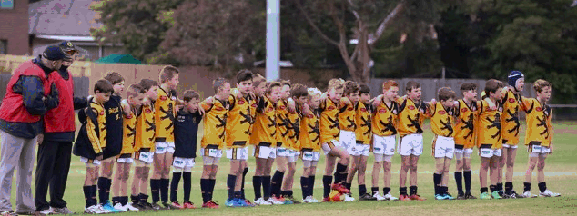
Back in the rooms the men could not wait to cheer the Gold and the Blue after securing the win and cementing top spot on the ladder...
*All events described above actually happened, though on occasion the author has taken certain, very small, liberties with the truth, because that is his right as a proud coach.
Thanks, Caesar
Caesar Ibrahim | National Dealer Business Operations Manager | Honda Australia
T: (61 3) 9285 5536 | M: 0428 697 794 | E: caesar.ibrahim@honda.com.au | W: www.honda.com.au/cars
Our dream is to leave blue skies for our children - please consider the environment before printing this email

