Hi Team Mores,
With Round one and our first win behind us, the boys were ready to take on Roxburgh Park in our first away game. It was a cold, wet and miserable
Sunday morning as the Heaters were set to high in the cars on the way to the match.
Kids were fired up and the first quarter was underway! Kicking with the wind the boys could not capitalise with a goal with the ball remaining in our forward
Half all quarter. Eager to prove they could mix it with the best, the boys set out to defend well in the second quarter and against the wind, kept play in our forward 50 for the majority of the quarter with a couple of tantalisingly close chances to score which just fell short.
It was time to get a score on the board in the third quarter, the kids decided that they would not be intimidated by the larger opposition (some of which looked
like they possibly drove themselves to the game) and with some huge Tackling efforts swung the tide and scored two goals in succession in the third. The boys were cold, wet, muddy and tired at the third change but buoyed by their massive third quarter were willing to run out the last quarter like champions. Roxburgh Park were not done and kicked a quick goal at the start of the fourth and penetrated the great wall a second time to come within 2 points. The troops bandied together for a tough slog out in the last few minutes to defend the small lead and secured the victory with a final score of 2.2-14 to 2.0-12.
The boys, covered in mud, sweat and the smell of victory marched off the ground cheering the Gold and the Blue after securing the win and top spot on the ladder...
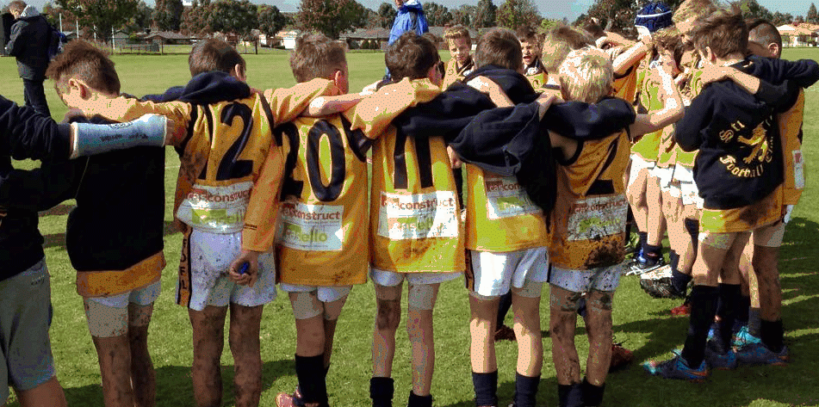
*All events described above actually happened, though on occasion the author has taken certain, very small, liberties with the truth, because that is his right as a proud coach.
Thanks, Caesar

